Name _________________________________ Date Due:
Algebra 1 Regents Review Packet #5
Directions: Choose the best answer. Answer ALL questions. Show ALL work in column 2. If there is no mathematical work to be shown, write an explanation or definition to support your answer!
1) The Utica Boilermaker is a 15-kilometer road race. Sara is signed up to run this race and has done the following training runs:
I. 10 miles
II. 44,880 feet
III. 15,560 yards
Which run(s) are at least 15 kilometers?
- I, only 3. I and III
- II, only 4. II and III

- Andy has $310 in his account. Each week, w, he withdraws $30 for his expenses. Which expression could be used if he wanted to find out how much money he had left after 8 weeks?
- 310 − 8w
- 280 + 30(w − 1)
- 310w – 30
- 280 − 30(w – 1)

- What is the product of 2x + 3 and 4x² − 5x + 6?
  - 8x³ − 2x² + 3x + 18
  - 8x³ − 2x² − 3x + 18
  - 8x³ + 2x² − 3x + 18
  - 8x³ + 2x² + 3x + 18

- What is the solution to 2h + 8 > 3h − 6?
- h < 14 3. h > 14
- h < $\frac{14}{5}$ 4. h > $\frac{14}{5}$
- Boyle’s Law involves the pressure and volume of gas in a container. It can be represented by the formula P₁V₁ = P₂V₂. When the formula is solved for P₂, the result is
- P₁V₁V₂ 3. 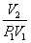
- 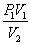 4. 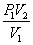
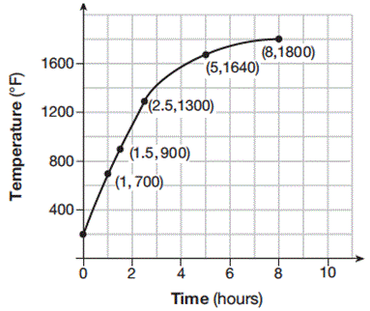
- Firing a piece of pottery in a kiln takes place at different temperatures for different amounts of time. The graph below shows the temperatures in a kiln while firing a piece of pottery after the kiln is preheated to 200ºF. During which time interval did the temperature in the kiln show the greatest average rate of change?
- 0 to 1 hour
- 1 hour to 1.5 hours
- 2.5 hours to 5 hours
- 5 hours to 8 hours
- How many of the equations listed below represent the line passing through the points (2, 3) and (4, −7)?
5x + y = 13
y + 7 = −5(x − 4)
y = −5x + 13
y − 7 = 5(x − 4)

- 1 3. 3
- 2 4. 4

- If the domain of the function f(x) = 2x² – 8 is {–2, 3, 5}, then the range is

- {–16, 4, 92} 3. {–16, 10, 42}
- {0, 10, 42} 4. {0, 4, 92}
- A satellite television company charges a one-time installation fee and a monthly service charge. The total cost is modeled by the function y = 40 + 90x. Which statement represents the meaning of each part of the function?

- y is the total cost, x is the number of months of service, $90 is the installation fee, and $40 is the service charge per month.
- y is the total cost, x is the number of months of service, $40 is the installation fee, and $90 is the service charge per month.
- x is the total cost, y is the number of months of service, $40 is the installation fee, and $90 is the service charge per month.
- x is the total cost, y is the number of months of service, $90 is the installation fee, and $40 is the service charge per month.

- If f(x) = $\frac{1 }{2 }$x² – ($\frac{1}{4}$x + 3), what is the value of f(8)?
  - 11 3. 17
  - 27 4. 33
- Which system of equations has the same solution as the system below?
2x + 2y = 16
3x − y = 4
- 2x + 2y = 16 3. 2x + 2y = 16
6x − 2y = 4 6x − 2y = 8

- x + y = 16 4. 6x − 6y = 48
3x − y = 4 6x + 2y = 8

- The volume of a large can of tuna fish can be calculated using the formula V = πr²h. (4pts)
PART A: Write an equation to find the radius, r, in terms of V and h.

PART B: Determine the diameter, to the nearest inch, of a large can of tuna fish that has a volume of 66 cubic inches and a height of 3.3

- Two friends went to a restaurant and ordered one plain pizza and two sodas. Their bill totaled $15.95. Later that day, five friends went to the same restaurant. They ordered three plain pizzas and each person had one soda. Their bill totaled $45.90. Write and solve a system of equations to determine the price of one plain pizza. [Only an algebraic solution can receive full credit.] (4pts)

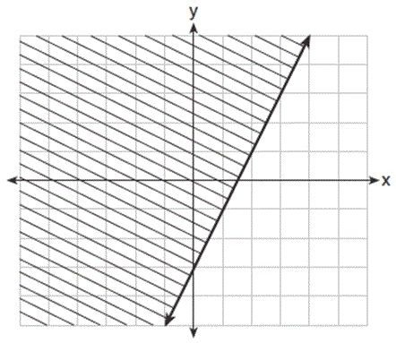
- The graph of an inequality is shown below. ( 6pts)
PART A:
Write the inequality represented by the graph.

PART B:
On the same set of axes, graph the inequality x + 2y < 4.

PART C:
The two inequalities graphed on the set of axes form a system. Oscar thinks that the point (2, 1) is in the solution set for this system of inequalities. Determine and state whether you agree with Oscar. Explain your reasoning.

15)One of the factors of 4x² – 9 is
- (x + 3)
- (2x + 3)
- (4x – 3)
- (x – 3)

